Product Scanner

Version <1.0>

Revision History

|  |  |  |  |
| --- | --- | --- | --- |
| **Date** | **Version** | **Description** | **Author** |
| 03/11/2017 | 1.0 | Initial use-case | Trần Nguyễn Hoàng Ân, Nguyễn Khương |
| 05/11/2017 | 1.1 | Edit use-case | Huỳnh Vĩnh Lộc, Nguyễn Thái Hưng |
|  |  |  |  |
|  |  |  |  |

Table of Contents

1. Use-case Model 4

2. Use-case Specifications 4

2.1 Use-case: Show list of price from different sources 4

Show list of price from different sources 4

View related product 5

2.3 Use-case: Add product to cart 5

Add product to cart 5

2.4 Use-case: Calculate total price 6

Calculate total price 6

2.5 Use-case: Add new product 6

2.6 Use-case: Review product 6

2.7 Use-case: Add new price to price list 7

2.8 Use-case: Review and approve for new contribute 7

Review and approve for new contribute 7

# Use-case Model

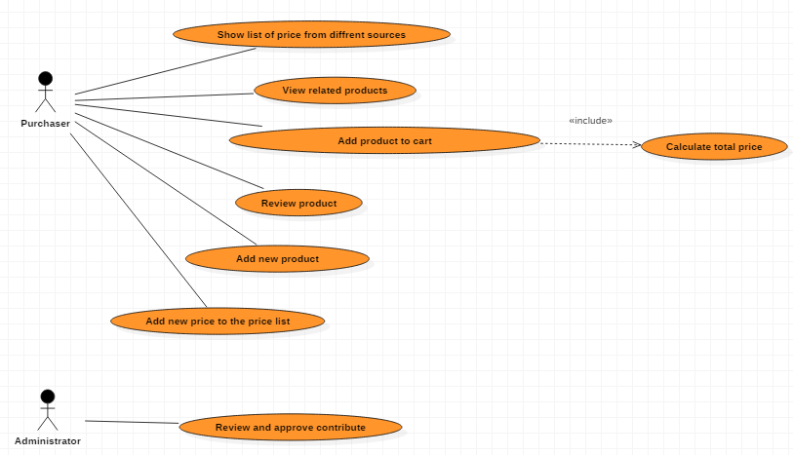

# Use-case Specifications

## Use-case: Show list of price from different sources

|  |  |
| --- | --- |
| Use case Name | Show list of price from different sources |
| Brief description | This use case describes how the Purchaser can see different prices of a product from many sources |
| Actors | Purchaser |
| Basic Flow | 1. Open app and choose scan 2. Scan barcode of product 3. System displays some information of product and then choose price 4. Showing the list of price (sorted from lowest to highest) and owning place |
| Alternative Flows | **Alternative flow 1: Can not find the product**   1. From step #3 of Basic Flow, if there is no product found, show the message 2. Choose add new product, or scan another barcode and continue step #3 |
| Pre-conditions | Actor goes to any place to scan a product’s barcode |
| Post-conditions | Purchasers know price from different places |

## 2.2 Use-case: View related products

|  |  |
| --- | --- |
| Use case Name | View related product |
| Brief description | This use case describes how the Purchaser can see products related to found product |
| Actors | Purchaser |
| Basic Flow | 1. Open app and choose scan 2. Scan the products 3. .System shows information of found product 4. Choose Suggestion to see list of related products |
| Alternative Flows | **Alternative flow 1: Can not find that product**   1. From step #3 of Basic Flow, show messages 2. Choose abort product or add new product 3. If choose add new product, continue step #2   **Alternative flow 2: Shopping cart has already contained that product**   1. From step #4 of Basic Flow, adjust new quantity of product 2. Continue step #5 of Basic |
| Pre-conditions | User want to add scanned products to cart |
| Post-conditions | The list of scanned products |

## Use-case: Add product to cart

|  |  |
| --- | --- |
| Use case Name | Add product to cart |
| Brief description | This use case describes how the Purchaser can add product to cart |
| Actors | Purchaser |
| Basic Flow | 1. Open app and choose scan 2. Scan the products 3. .System shows information of found product 4. Choose Add to cart 5. Choose the quantity for that product 6. Choose Add to complete the adding job |
| Alternative Flows | **Alternative flow 1: Can not find that product**   1. From step #3 of Basic Flow, show messages 2. Choose abort product or add new product 3. If choose add new product, continue step #2   **Alternative flow 2: Shopping cart has already contained that product**   1. From step #4 of Basic Flow, adjust new quantity of product 2. Continue step #5 of Basic |
| Pre-conditions | User want to add scanned products to cart |
| Post-conditions | The list of scanned products |

## 

## Use-case: Calculate total price

|  |  |
| --- | --- |
| Use case Name | Calculate total price |
| Brief description | This use case describes how the Purchaser can know the total price of all products in the cart |
| Actors | Purchaser |
| Basic Flow | 1. Open app and choose My cart 2. Choose Total to see the total price |
| Alternative Flows | **Alternative flow 1: The shopping cart has not contained any product**   1. From step #2 of Basic Flow, Choose scan product to find and add to cart 2. Continue step #2 of Basic Flow |
| Pre-conditions | User want to know the total price of all products in the cart |
| Post-conditions | Total price is calculated and showed |

## Use-case: Add new product

|  |  |
| --- | --- |
| Use case Name | Add new product |
| Brief description | This use case describes how the Purchaser can add new products |
| Actors | Purchaser |
| Basic Flow | 1. Scan product 2. If it can not find any product, sign in 3. Fill some information of product (price, place, review…) |
| Alternative Flows | No alternative flow |
| Pre-conditions | Actor scan a product’s barcode |
| Post-conditions | Products are sent to admin to accept |

## Use-case: Review product

|  |  |
| --- | --- |
| Use case Name | Review product |
| Brief description | This use case describes how the Purchasers see reviews of other users or give their reviews |
| Actors | Purchaser |
| Basic Flow | 1. Open app and choose scan 2. Scan barcode of product 3. System displays some information of product 4. Choose comment to see previous evaluation 5. Users may comment their reviews |
| Alternative Flows | **Alternative flow 1: Can not find product**   1. From step #3 - Basic Flow, scan another product or add new one 2. Continue step #5 - Basic Flow   **Alternative flow 2: Account is not signed in**   1. From step #4, Sign in 2. Continues step #5 |
| Pre-conditions | Actor goes to any place to scan a product’s barcode and then he/she want to know the using experience from other users or give own comments |
| Post-conditions | Actor grasp the quality of product through comments of previous users or give the review about product |

## 

## Use-case: Add new price to price list

|  |  |
| --- | --- |
| Use case Name | Add new price to price list |
| Brief description | This use case describes how the Purchaser/ Market’s Owner can add new products |
| Actors | Purchaser |
| Basic Flow | 1. Scan product 2. If it can not find the price with place, choose Add new price 3. Fill price and selling place |
| Alternative Flows | No alternative flow |
| Pre-conditions | Actors have found a product but the price list do not include the price that they see |
| Post-conditions | New price is sent to admin to accept |

## Use-case: Review and approve for new contribute

|  |  |
| --- | --- |
| Use case Name | Review and approve for new contribute |
| Brief description | This use case describes how the Administrator can review all new products or prices added by users and decide whether they add them to data or not |
| Actors | Administrator |
| Basic Flow | 1. Scan product 2. If it can not find the price with place, choose Add new price 3. Fill price and selling place |
| Alternative Flows | No alternative flow |
| Pre-conditions | Actors have found a product but the price list do not include the price that they see |
| Post-conditions | New price is sent to admin to accept |